Create OTA package
Firstly, generating an OTA package requires three important files
resource.json This file is a configuration file and does not require manual modification.
Package script:package_resource.ps1/package_firmware.ps1 This is a script file that runs on PowerShell
Original File:
Fireware Original File:: Firmware_Version.bin
Firmware_V0.0.1.bin
Cert and Param Original File:: CertParam_Version.zip
CertParam_V0.0.1.zip
Voice Original File:: Voice_Version.zip
Voice_V0.0.1.zip
The version number is required when naming the file above. The file suffix type should be consistent
- Create OTA firmware package
- Firstly, place the bin file generated in step 4 of project-build.bat into the tms/firmware directory And modify the file name as required.
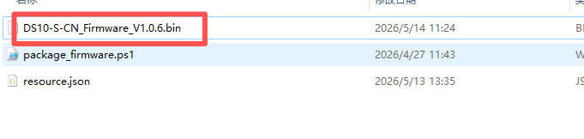
- Open PowerShell and run package_firmware. ps1. The script requires three parameters to be entered
- Original files that need to be packaged 2 Device Mode 3 Customer Name
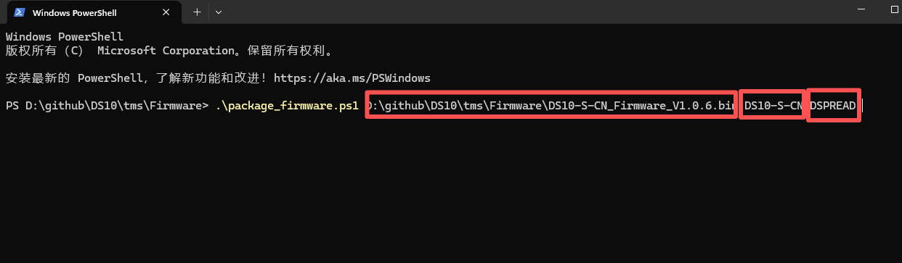
- After completing the parameter input, press enter to execute the script, which will automatically generate an OTA firmware package that can be uploaded to the TMS system.
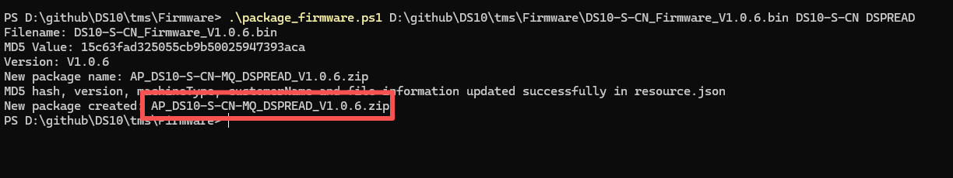
- AP_DS10-S-CN-MQ_DSPREAD_V1.0.6.zip It is a generated OTA firmware package that can be uploaded to the TMS system for updating device firmware.
- Create Cert and Param OTA package
- About tms/CertParam/ ResourceFile/posparam.ini
posparam.ini is JSON fomart.
The following is a list of parameters that support remote updates
Param Name | Type
MqttUrl | String | MQTT server address
MqttPort | String | MQTT server port
username | String | Username for connecting to MQTT server
password | String | Password for connecting to MQTT server
clietId | String | ClientId for connecting to MQTT server  In general, no setting is required, SN is used as the client ID by default in the firmware
Topic | String | It is the base topic, and the device will  automatically append its own SN to form the final subscription topic  Example;user/message/sn
LogStatus | Int | 0: Release  2:Debug
CertState | Int | 0: No certificate needs to be set up  1: A certificate needs to be set up
- About original Cert and Param files
If set CertState with 0,
posparam.in file is needed to create CertParam_V1.0.6.zip
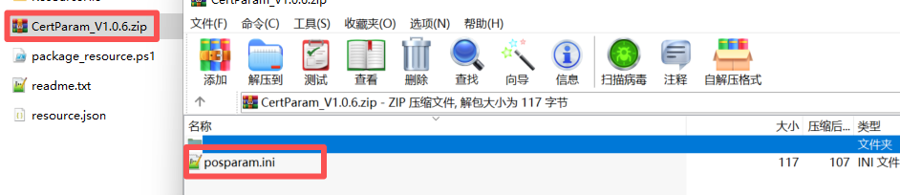
Please note that the zip file only contains the posparam.ini file Cannot contain other folders
If set CertSate with 1 posparam.iniand cert files are needed to create CertParam_V1.0.6.zip
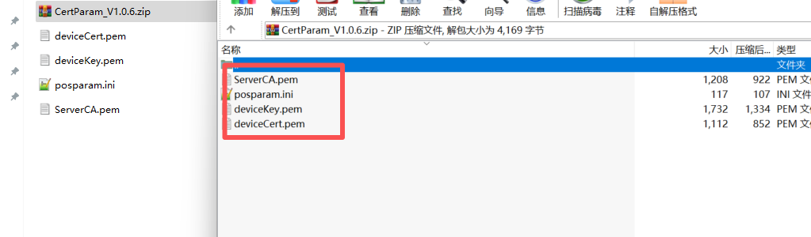
- Open powershell and run ./CertParam/package_resource.ps1
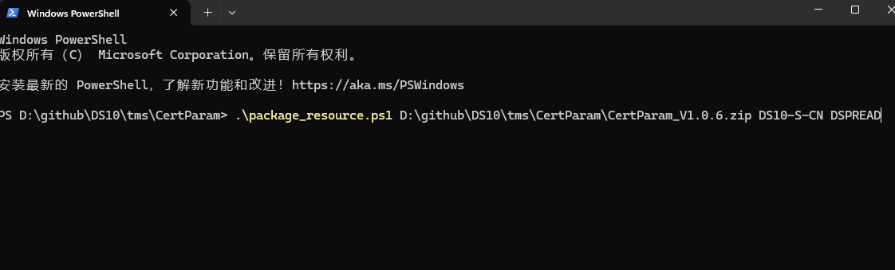
- Create Cert and Param OTA package.
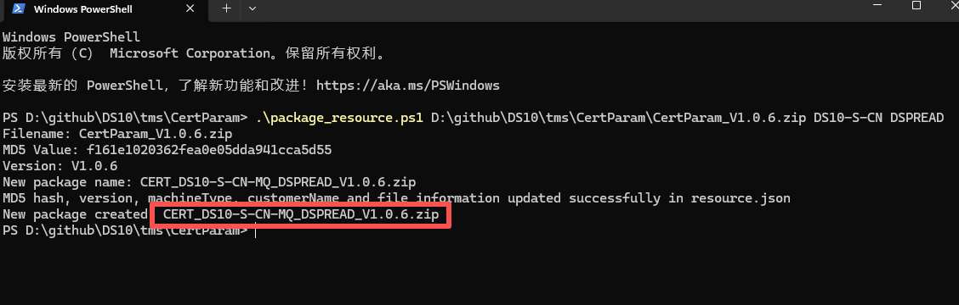
- Create Voice OTA package
The device supports updating played voice files through TMS. Support single file and batch file updates.
- Orignal voice files: tms/VoiceResource/voice
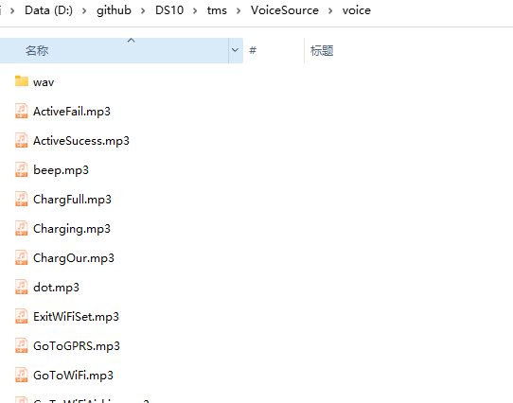
- Create Voice Original files,
map3 and wav files are needed to create VoiceResource_V1.0.6.zip
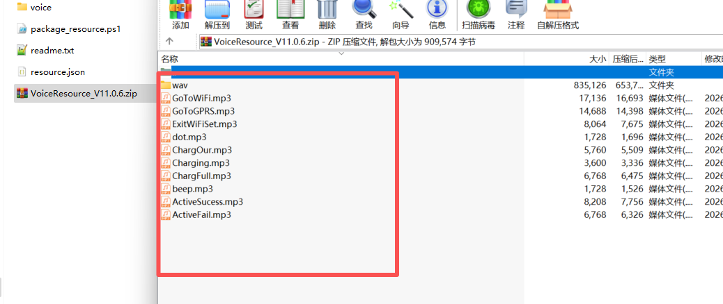
- Open powershell and run package_resource.ps1
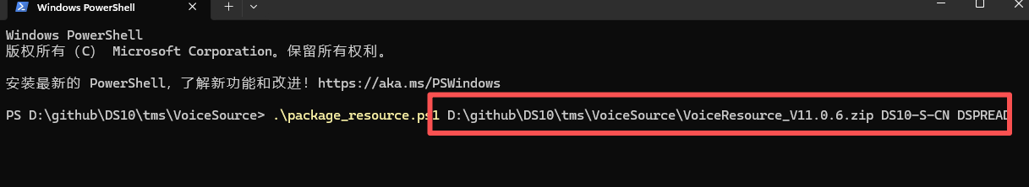
- Create Voice OTA package
